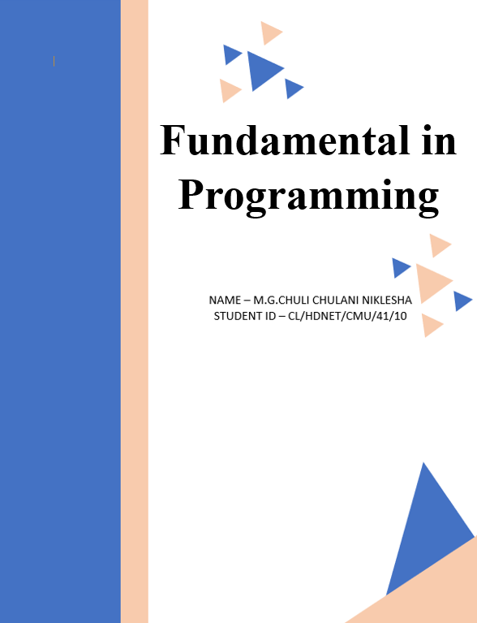

**Assignment Cover Sheet**

|  |  |  |  |
| --- | --- | --- | --- |
| **Qualification** | | **Module Number and Title** | |
| HD in Computing and Software Engineering /Network Technology and Cyber Security | | CSE 4002  Fundamentals in Programming | |
| **Student Name & No.** | | **Assessor** | |
| Name – M.G.Chuli Chulani Niklesha  CL/HDNET/CMU/41/10 | | Mrs. Vindya | |
| **Hand over date** | | | **Submission Date** |
|  | | |  |
| **Assessment type** | **Duration/Length of**  **Assessment Type** | | **Weighting of Assessment** |
| **Coursework** | Software Submission and demonstration | | 100% |

|  |  |
| --- | --- |
| **Learner declaration** | |
| I am Chuli Chulani Niklesha(CL/HDNET/CMU/41/10) certify that the work submitted for this assignment is my own and research sources are fully acknowledged. | |
| |  |  |  |  | | --- | --- | --- | --- | | **Marks Awarded** | | | | | First assessor | |  | | | IV marks | |  | | | Agreed grade | |  | | | Signature of the assessor |  | Date |  | |

**Feedback Form**

**International College of Business & Technology**

**Module:** CSE 4002

**Student:** M.G. Chuli Chulani Niklesha

**Assessor:** Mrs. Vindya

**Assignment:** Nethra bookshop automation system

**Assessor Feedback:**

**Marks Awarded:**

Contents

**Introduction** 5

**Acknowledgment** 5

**Task 01** 6

1.1 System Requirement Specification Document 6

1.1.1 Introduction 6

1.1.2 Purpose 6

1.1.3 Functional Requirements 6

1.1.4 Non-Functional Requirements 7

1.2 Flowcharts 8

1.2.1 admin() 8

1.2.2 user() 9

1.2.3 userWorkSpace() 10

1.2.4 loginAdmin() 11

1.2.5 table() 12

1.3 Pseudocodes 13

1.3.1 loginAdmin() 13

1.3.2 loginUser() 14

1.3.3 table() 15

**TASK 02** 16

2.1 Implementation Details 16

a) Screenshots of Sequence / Selections / Repetition 16

b) Screenshots of Functions 20

c) Screenshots of Arrays 21

**TASK 03** 22

Test Document of the Bun Talk Billing System 22

3.1 Introduction 22

3.2 Test Cases 23

3.3 The results of each relevant test case 23

3.3.1 Admin’s login 23

3.3.2 Admin’s Registration 23

3.3.3 User’s Login 24

3.3.4 User’s Exit 25

3.3.5 Admin’s entering username and password 26

3.3.6 Admin’s Dashboard 26

3.3.7 User’s Dashboard 27

3.3.8 Search Book 28

3.3.9 Search Book wrong ID 29

3.3.10 Insert Book 29

3.3.11 Update Book 30

3.3.12 Delete Book 31

3.3.13 View Orders 31

3.3.14 Make Orders 32

3.3.15 Print Bill 33

3.4 User Acceptance Testing Questionnaires 33

**REFERENCES** 35

# **Introduction**

Nethra is one of the famous bookshops in Kandy. Until now the system of Nethra Bookshop was maintained manually. This assignment gives a better idea about automating that manually operated system. First, the SRS document is provided. The second is to outline the operations that take place in various unique sections of the constructed system. Lastly, a user acceptance test document and a test plan are added to verify that the system is developed correctly and that it is suitable for the intended user.

# **Acknowledgment**

I want to express my gratitude to Ms. Vindya, our Fundamentals in Programming lecturer, for her guidance and assistance with this work. Her notes proved to be a valuable resource in finishing this task.

# **Task 01**

## 1.1 System Requirement Specification Document

### 1.1.1 Introduction

Nethra is one of the famous bookshops in Kandy City, which provides a vast range of valuable books for schools, and educational institutes as well as to daily customers. They used manual methods to run the entire business process from the cashier to the back office. However due to some factors, they have decided to automate their entire system.

1. Rapidly increasing customer inquiries.
2. Customers place large orders and request quotes quickly, but manual quotes are often inaccurate.

These can be pointed out as reasons for automating the system. The purpose of this system is to automate the entire manual work and save time and cost. This automated system will be able to provide a better service to their customers. The SRS lists the primary functional requirements, non-functional requirements, and system limitations for the proposed system. It will be very beneficial for the development process that the SRS additionally includes pseudocode and flowcharts for every major system function.

### 1.1.2 Purpose

Nethra's manual system is riddled with errors. such is having trouble keeping track of orders, doing calculations wrong, copying data, being ineffective, having unhappy customers, and misplacing paperwork. They have made the financial decision to automate their manual system to address these issues.

### 1.1.3 Functional Requirements

As a book shop, Nethra’s automated system should have different types of functional needs. Some of the main parts are below.

1. Manage Books
2. Create Orders
3. Print receipt with discount

* Manage Books

Nethra’s automated system has two stakeholders. They are admins and users. This book manage part is done by administrators. Here, admins can insert books, search the details of inserted books, update details, delete books and view the orders.

* Create Orders

Actually, this is done by the users. They can choose the books from our store and give the number of books that he want as the quantity. The system has given to the admin the ability to monitor the orders placed by these users through his dashboard.

* Print Receipts

After giving the quantity the system asked form the user that do you want to add another book. Then the user can add a book or get the receipt for his order. Here, if the user buys books worth more than one thousand and hundred rupees, he will get a 5% discount. And also, the user buy books worth than three thousand rupees, he will get a 10% discount and he buy books worth than five thousand rupees; he will get a 20% discount.

### 1.1.4 Non-Functional Requirements

1. The system ought to respond to all user requests, including login, book addition, book updating, bill generation, and so on, in less than three seconds.
2. To promote ease of use, the user interface needs to be user-friendly.
3. The system ought to offer unambiguous error notifications and prompts for remedial measures.

## 1.2 Flowcharts

### 1.2.1 admin()

### 1.2.2 user()

### 1.2.3 userWorkSpace()

### 

### 1.2.4 loginAdmin()

### 

### 1.2.5 table()

### 

## 1.3 Pseudocodes

### 1.3.1 loginAdmin()

FUNCTION loginAdmin()

DECLARE count = 0 , userID = "" , password = "" , id = "" , pass = ""

DISPLAY "Please Enter Username and Password:"

DISPLAY "XXXXXXXXXXXXXXXXXXXXXXXXXXXXXXXXXXXXXXXX"

DISPLAY "Remember you have only three attempts to insert your username and password!"

DISPLAY "So, please insert your username and password with attention"

DISPLAY "XXXXXXXXXXXXXXXXXXXXXXXXXXXXXXXXXXXXXXXX"

FOR i = 1 to 3

DISPLAY "USERNAME: "

READ userID

DISPLAY "PASSWORD: "

READ password

OPEN input file "adminRecords.txt"

WHILE (Read id, pass from input file)

IF (id is equal to userID and pass is equal to password)

SET count to 1

END IF

END WHILE

CLOSE input file

IF (count is equal to 1)

CALL Head()

DISPLAY "Your login is successful, " + userID

CALL adminWorkSpace()

ELSE

DISPLAY "Login error"

DISPLAY "Please check your username and password"

END IF

END FOR

ENDFUNCTION

### 1.3.2 loginUser()

FUNCTION loginUser()

DECLARE count = 0 , userID = "" , password = "" , id = "" , pass = ""

DISPLAY "Please Enter Username and Password:"

DISPLAY "XXXXXXXXXXXXXXXXXXXXXXXXXXXXXXXXXXXXXXXX"

DISPLAY "Remember you have only three attempts to insert your username and password!"

DISPLAY "So, please insert your username and password with attention"

DISPLAY "XXXXXXXXXXXXXXXXXXXXXXXXXXXXXXXXXXXXXXXX"

FOR i = 1 to 3

DISPLAY "USERNAME: "

READ userID

DISPLAY "PASSWORD: "

READ password

OPEN input file "userRecords.txt"

WHILE (Read id, pass from input file)

IF (id is equal to userID and pass is equal to password)

SET count to 1

END IF

END WHILE

CLOSE input file

IF (count is equal to 1)

CALL Head()

DISPLAY "Your login is successful, " + userID

CALL userWorkSpace()

ELSE

DISPLAY "Login error"

DISPLAY "Please check your username and password"

END IF

END FOR

ENDFUNCTION

### 1.3.3 table()

FUNCTION table()

CLEAR SCREEN

CALL Head() FUNCTION

DECLARE VARIABLES: bid AS INT, name, aname, pname AS STRING, pprice AS FLOAT

Open FILE "books.txt" IN INPUT MODE AND ASSIGN IT TO THE 'products' FILE STREAM

DISPLAY "Products List" with appropriate formatting

DISPLAY AS TABLE HEADERS: "Book ID", “Book Name", “Author Name”, “Publisher Name”, "Price"

WHILE (products IS OPEN)

READ bid, name, aname, pname and price

DISPLAY name, aname, pname and price

END WHILE

CLOSE 'books' FILE

END FUNCTION

# **TASK 02**

## 2.1 Implementation Details

### (a) Screenshots of Sequence / Selections / Repetition

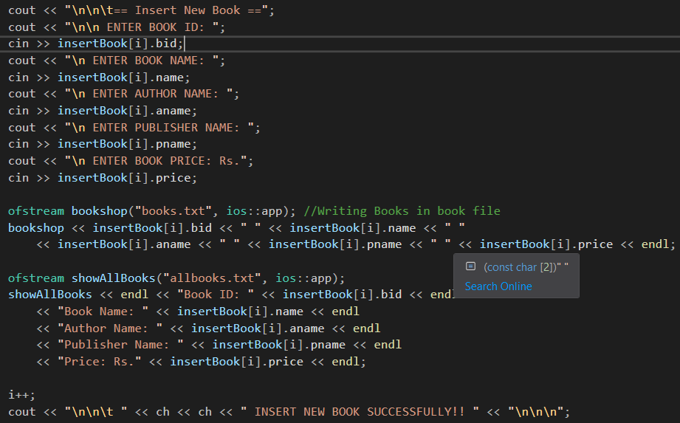 Sequence – 01

* In inserting a book into the system, the admin has to give the details of the relevant book. Such as book ID, name, author name, publisher name, and price, etc. After inserting these details by the user, the information is written in a file called “books.txt”. And the system gives an ability to the admin to show all books in instantly. Therefore that inserted information is also written in a file called “allbooks.txt”.

Sequence – 02

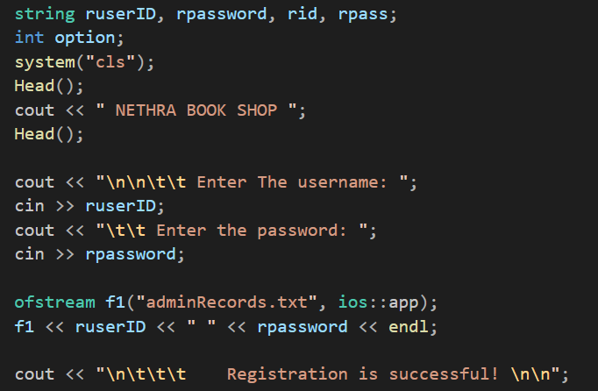

* This is a part of the registration function. Here user has to enter a username and password. And that information is written in a file called “adminRecords.txt”. And system shows a message called “Registration is successful”.

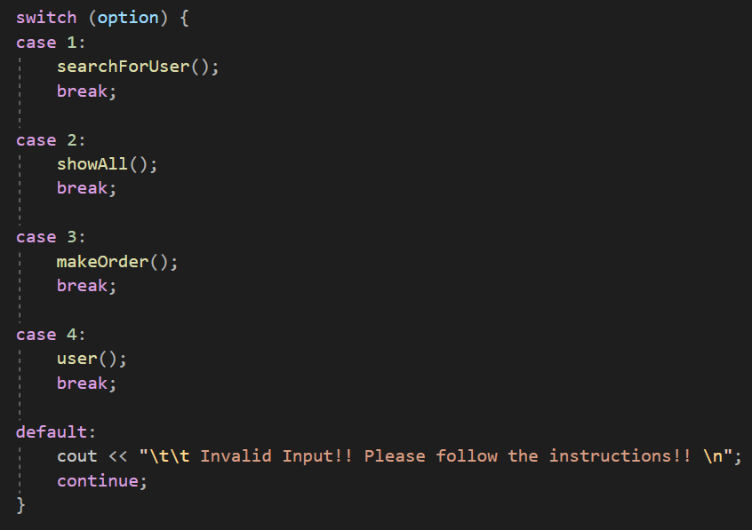Selection – 01

* This is a code part of user dashboard. Actually, this is an example for a selection type of switch case. There are four cases in this switch case. The first case is searching books. The second is to show all books. The third one is making an order and the fourth one is logout (user). If the user enters a number that is out of this range, the system generates a message called “Invalid Input”.

Selection – 02

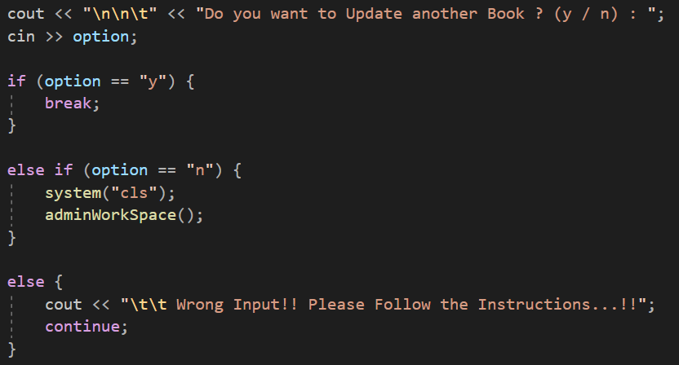

* This is a part of the update book function. Here system asks form the system that “Do you want to update another book?”. Actually, this is an example of nested else if. If the user press “y”, the statement will break and execute the code part of out the statement. If the user enters “n”, the system calls to the adminWorkSpace function.

Repetition – 01

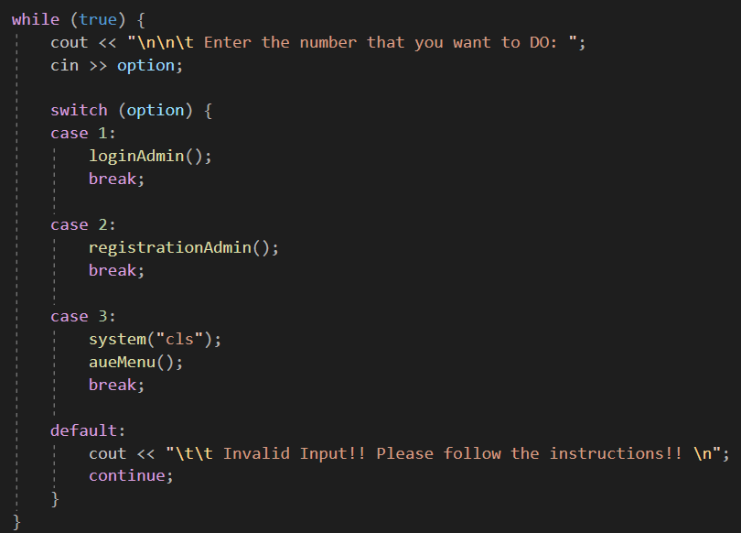

* This is an example of a while loop. Actually, this can be considered an always-true loop. Here first system asks from the user that Enter the number that you want to do. After that run the switch case statement. There is a continue keyword here. Continue and break statements are available only in loops. That’s why I used a infinite while loop here.

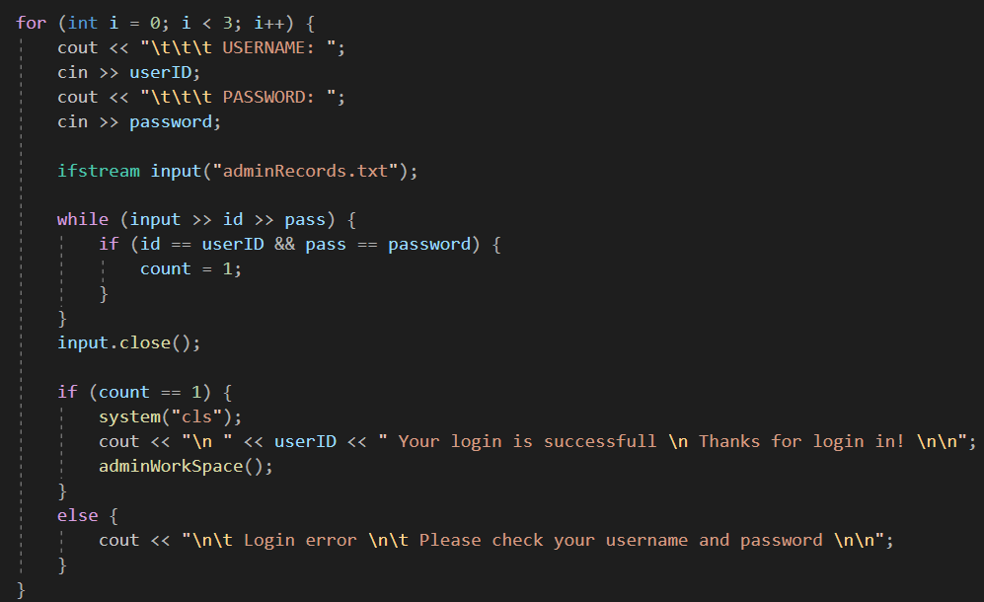Repetition – 02

* This is an example of a for loop. Actually this is a part of login function. Here loop execute three times. System give three opportunities to user to give the username and password correctly. If the user can not give the correct username and password within these three attempts, System end automatically and the user have to run the program again.

### b) Screenshots of Functions

Function – 01

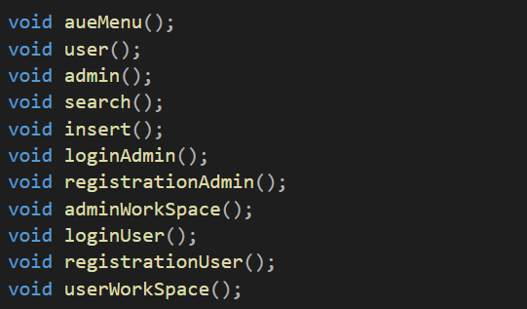

* These are some functions for using to modularize the entire code. Here aeuMenu is used to show first menu. And user function is used to build user’s part and etc.

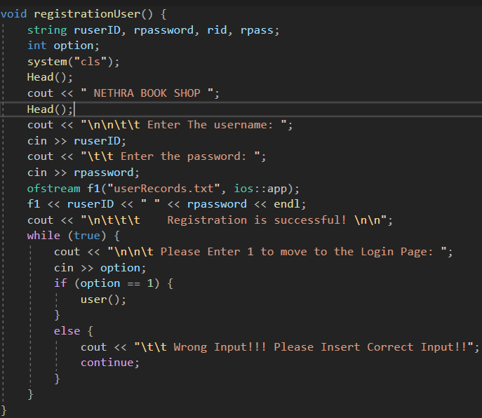Function – 02

* This is the function that is used to execute the registration process of the users. Here first user has to enter his username and password. After entering the username and password, they are written in a file called “userRecords.txt”.

### c) Screenshots of Arrays

Arrays – 01

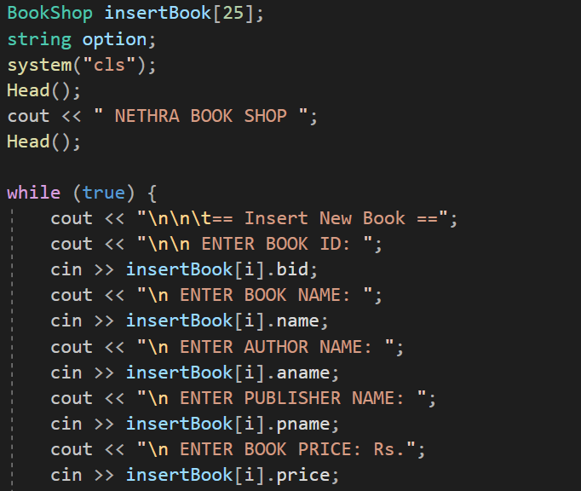

* This is a part of the insert book function. There is an array called insertBook here. When the user gives the data, this array store those data temporarily.

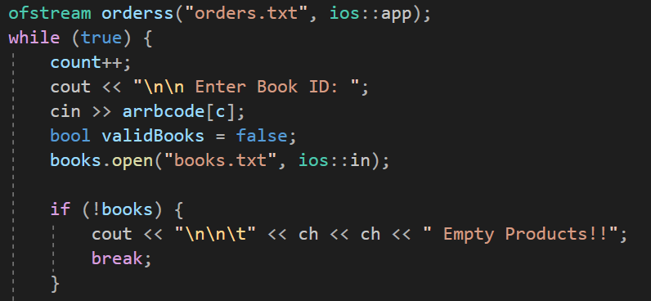Array – 02

* Here, There is an array called arrbcode for storing the book ID for creating bill purposes. Those relevant book IDs will be gotten from the file called books.txt. Usually, arrays are used for storing the data temporarily.

Structures

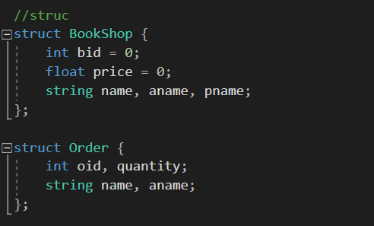

* There are two structures in my code called BookShop and Order. Structures are usually used for when variables of different data types need to be filed under a single name.

# **TASK 03**

# Test Document of the Bun Talk Billing System

## 3.1 Introduction

This test document aims to provide an overview of the Nethra bookshop's system's testing methods, test cases, sample questionnaires, and procedures. Should any issues arise with the software system constructed using this document, they can be resolved, enabling the system's end users to produce high-caliber software.

Scope - This automated system has two stakeholders. They are both users and administrators. Admins should be allowed to log in and create new accounts in this system login section. Other administrative functions, such as adding, changing, removing, and double-checking added books, can be shown here. Additionally, cashiers have access to the system entry area's administrator credentials. Other user capabilities include the ability to create orders and bills using those orders.

## Test Cases

The settings selected to assess the built-in software application's functioning and performance are called test cases. Test cases are mostly used to make sure the software performs as intended.

## The results of each relevant test case

### Admin’s login

|  |  |
| --- | --- |
| Test No. | Case 1 |
| Scenario | Administrator’s login page  After opening the Nethra book shop automated system, select the role as “Admin”. Press one for that. Then the user falls into the Administrator’s login section. |
| Expected Result | Showing the administrator’s login section page. The administrator should be able to log in to the system, register to the system, and exit from the system. |
| Actual Result |  |
| Status | Pass |

### Admin’s Registration

|  |  |
| --- | --- |
| Test No. | Case 2 |
| Scenario | Administrator’s registration  To register for the system, access the administrator's login page and hit two. Here, the user must provide the system with their account and password. |
| Expected Result | After the user enters the username and password, the system shows a message that “Registration is successful!” |
| Actual Result |  |
| Status | Pass |

### User’s Login

|  |  |
| --- | --- |
| Test No. | Case 3 |
| Scenario | User’s login section  After opening the Nethra book shop automated system, select the role as “User”. Press two for that. Then the user falls into the User’s login section. |
| Expected Result | Showing the user’s login section page. Also the user should be able to log in to the system, register to the system, and exit from the system. |
| Actual Result |  |
| Status | Pass |

### User’s Exit

|  |  |
| --- | --- |
| Test No. | Case 4 |
| Scenario | User’s exit  After falling the User’s login section, May he want to exit from the system. For that the user can press number three. |
| Expected Result | Showing a message called “Thank you!! Have a great day!! And should be finished the process of executing. |
| Actual Result |  |
| Status | Pass |

### Admin’s entering username and password

|  |  |
| --- | --- |
| Test No. | Case 5 |
| Scenario | Entering username and password  After falling admin login section, the user can login to the system. For that he can press number one and give the username and password correctly. |
| Expected Result | If the user can’t give the correct username and password within three attempts, the system will break automatically and print a message called “Your attempts are finished!! Please re-start the program”. |
| Actual Result |  |
| Status | Pass |

### Admin’s Dashboard

|  |  |
| --- | --- |
| Test No. | Case 6 |
| Scenario | Admin Dashboard  After giving the username and password correctly, the admin can move to the admin dashboard. |
| Expected Result | After giving the correct username and password, the system shows a message called “Your login is successful” with the inserted username. And show the admin dashboard. |
| Actual Result |  |
| Status | Pass |

### User’s Dashboard

|  |  |
| --- | --- |
| Test No. | Case 7 |
| Scenario | User Dashboard  After giving the username and password correctly, the user can move to the user dashboard. |
| Expected Result | After giving the correct username and password, the system shows a message called “Your login is successful” with the inserted username. And show the user dashboard. |
| Actual Result |  |
| Status | Pass |

### Search Book

|  |  |
| --- | --- |
| Test No. | Case 8 |
| Scenario | Search Book  This function has both admin and user. After selecting the search book option, first user has to insert a book ID, then he can get the details of that relevant book. |
| Expected Result | After giving a valid book ID, the system show the details of the book. Such as ID, name, author name, publisher name, and price, etc. |
| Actual Result |  |
| Status | Pass |

### Search Book wrong ID

|  |  |
| --- | --- |
| Test No. | Case 9 |
| Scenario | Search Book wrong ID  When searching a book, if the user enters an invalid book ID, the system will show an error message like “Wrong Book ID!! Please Check Again!!” |
| Expected Result | Error message |
| Actual Result |  |
| Status | Pass |

### Insert Book

|  |  |
| --- | --- |
| Test No. | Case 10 |
| Scenario | Insert Book  This function has only admin. After selecting the insert book option, the admin has to insert some details of the book. Such as ID, name, author name, publisher name and price. |
| Expected Result | After giving those details print a message like “Insert Book Successfully” |
| Actual Result |  |
| Status | Pass |

### Update Book

|  |  |
| --- | --- |
| Test No. | Case 11 |
| Scenario | Update Book  This function has only admin. After selecting the update book option, the admin has to insert the book ID first. After system show the details of that book. And the system allows changing the details. |
| Expected Result | The system allows changing the details. |
| Actual Result |  |
| Status | Pass |

### Delete Book

|  |  |
| --- | --- |
| Test No. | Case 12 |
| Scenario | Delete Book  This function has only admin. After selecting the delete book option, the admin has to insert the book ID first. After the system shows the details of that book and deletes those details from the system. |
| Expected Result | The system allows deleting the details. |
| Actual Result |  |
| Status | Pass |

### View Orders

|  |  |
| --- | --- |
| Test No. | Case 13 |
| Scenario | View Orders  This function has only admin. After selecting the view orders option, the system shows the orders that are done by users |
| Expected Result | Relevant book id and quantity |
| Actual Result |  |
| Status | Pass |

### Make Orders

|  |  |
| --- | --- |
| Test No. | Case 14 |
| Scenario | Make Orders  This function has only users. After selecting the make orders option, the system shows the books details in a table. |
| Expected Result | Book details in a table and the ability to enter book ID and quantity |
| Actual Result |  |
| Status | Pass |

### Print Bill

|  |  |
| --- | --- |
| Test No. | Case 15 |
| Scenario | Print Bill  This function has only users. After giving book ID and quantity, system prints the bill. |
| Expected Result | The receipt |
| Actual Result |  |
| Status | Pass |

## 3.4 User Acceptance Testing Questionnaires

Role / Position –

Name –

Email –

Contact –

* Underline your answer

1. Overall Satisfaction

i. On a scale of 1 to 5, how satisfied are you with this system?

* Very Dissatisfied
* Dissatisfied
* Normal
* Satisfied
* Very Satisfied

1. User Interface

ii. Did you find the system easy to use?

* Yes
* No

If no, please describe what parts need improvement.

1. Billing Process

iii. Were you able to generate bills without any difficulties?

* Yes
* No

If no, please describe what parts need improvement.

iv. Were the billing calculations accurate?

* Yes
* No

If no, please specify any inaccuracies you noticed.

1. Performance and Speed

v. Did you experience any performance issues, such as slow loading times?

* Yes
* No

If yes, please describe those the performance issues.

vi. Having problems updating, deleting books in this system?

* Yes
* No

If yes, please explain what those problems.

vii. Having problems entering books to create the bill?

* Yes
* No

If yes, please explain what those problems.

1. Additional Comments

viii. Do you have any additional comments, suggestions for improvement, or features you'd like to see added to this system?

# **REFERENCES**

* Bandakkanavar, R. (2023) *Software requirements specification document with example*, *Krazytech*. Available at: https://krazytech.com/projects/sample-software-requirements-specificationsrs-report-airline-database (Accessed: 04 January 2024).
* Pawlicka, A. (2023) *HOW TO WRITE PROJECT SCOPE in software development*, *Selleo*. Available at: https://selleo.com/blog/how-to-write-project-scope-in-software-development (Accessed: 05 January 2024).

